

**OBJECTIVES:**

Upon successful completion of this experiment, the student will be able to:

1. Describe the parameters of nominal T and pi transmission line
2. Solve problems involving nominal T and pi network transmission line.
3. Illustrate with correct label and dimension.
4. Differentiate the operating characteristics and the over-all results between the two networks.

**SUMMARY OF THEORY**

Applicable from 80 km to lines up to 240 km long. Equivalent circuit of medium transmission line consists of nominal PI and the nominal T connections. The shunt admittance, usually pure capacitance, is included in the calculations. For nominal as shown in the figure below the shunt admittance is halve in the two branches. While for nominal T connection it is the line impedance that halved into two parts!

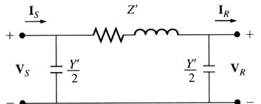

**Problem 01:** A 3 phase 60 Hz line is 100 miles long. The sending end voltage is 220 kV. Resistance = 0.2 ohms per mile; inductive reactance = 0.8 ohm per mile and admittance = 5.3 x 10-6 mho per mile. Find the sending end current when there is no load on the line. ( Use nominal T connection )

**Problem 02:** If the load on the line described in problem 01 is 80 MW at 220 kV, unity power factor. Calculate the current, voltage and power at sending end.

**Problem 03**: A 3 phase 60 Hz line is 100 miles long. The sending end voltage is 220 kV. Resistance = 0.2 ohms per mile; inductive reactance = 0.8 ohm per mile and admittance = 5.3 x 10-6 mho per mile. Find the sending end current when there is no load on the line. (Use nominal pi connection )

**Problem 04**: If the load on the line described in problem 01 is 80 MW at 220 kV, unity power factor. Calculate the current, voltage and power at sending end.

AFTER YOUR SOLUTION AND COMPUTATIONS, IN THREE PARAGRAPHS WRITE YOUR OBSERVATIONS AND A MAXIMUM OF TWO SENTENCES YOUR CONCLUSION.

Solution/Computations starts here:

